Discussion
During this unit, you will learn about many different types of graphs, which graphs are most appropriate for specific data, and when graphs are misleading. For instance, a graph can misrepresent the data if it does not provide a proper representation of the data, which can be caused by the vertical scale being too small or too large, or by not starting at 0. Additionally, if a graph does not have the proper labels or if data is left out, this can also result in a graph that does not properly represent the data.
- What story does this visual display (graph) below tell? Describe the variables that are being compared. (Hint: There are three). Do you think that this is an accurate and fair description of the data? Is this graph clear or misleading? Why?
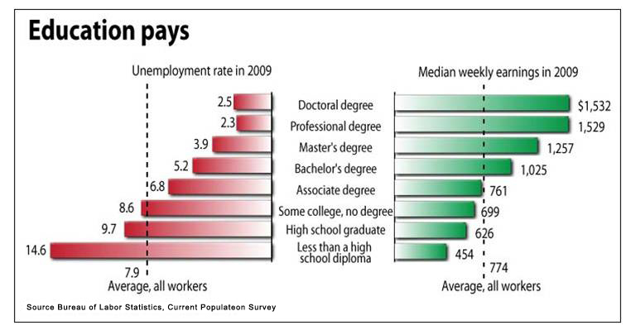

Source: http://calculatedriskimages.blogspot.com/2010/09/bls-education-pays.html
2. What story does the Pie Graph below tell? Describe what these data are representing. Do you think that this is an accurate and fair description of these data? Is this graph easy to understand? Name at least three things wrong with this graph and how you might correct them?
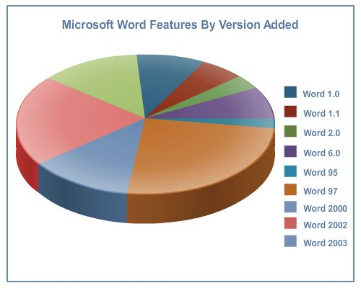

Source: http://blog.jgc.org/2009/08/please-dont-use-pie-charts.html
3. Choose any Excel dataset from Doc Sharing. Include the name of the dataset. From that dataset, select any qualitative and discrete variable and create an appropriate graph that describes that variable. Be sure to fully label the graph. Attach your graph to your post using Add/Remove. (Note: Doc Sharing contains tutorials to help with graphing in Excel).
In this week’s Discussion, you will interact with your classmates on the course content. Remember that your goals for Discussion are the following:
- Get involved throughout the entire unit. Remember to try to make your initial or main post no later than Sunday night to give your classmates an opportunity to respond and collaborate.
- Contribute to the Discussion by sharing knowledge, creating a community, asking questions, helping others, and posting at least two student responses that move the discussion forward.
- Use course material, unit topics, textbook references, and scholarly publications to support and explain your ideas, posts, and responses. Do not forget to properly reference any resources that you use.
- To assure that you are actively participating and contributing to the Discussion, try to post on at least three different days out of the unit. Be sure your posts are grammatically correct, spell checked, and fully answer all of the questions asked.

